# Writing Assignment – Results Memo (brief 2-page written (plus plots, pseudocode, and C program-listing))

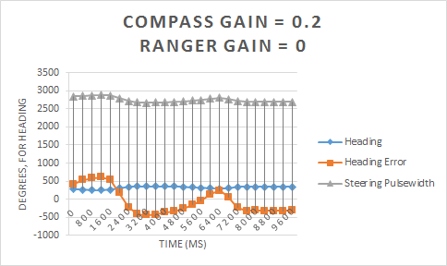

With the first set of data points, beginning with a compass gain of 0.2 and the ranger gain set to 0, the heading and the ranger values both stabilize and remain relatively linear. The heading error also maintains at approximately 8000ms. The steering pulsewidth is also very linear, while the heading error is shakier.

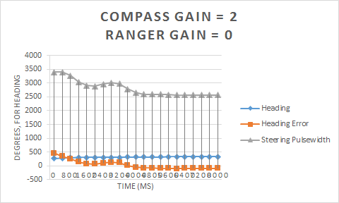

With a compass gain of 2 and a ranger gain of 0, the heading stabilizes in a more linear fashion than compared to the previous graph. The heading error also maintains at around 5600ms, 2400ms shorter than the prior entry of 8000ms. The steering pulsewidth also becomes slightly shaky and the heading error more linear, the vice versa of the previous diagram.

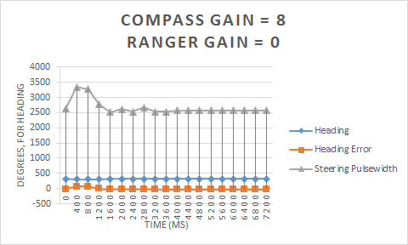

The trends shown in the prior two graphs continue, where the heading and heading error are almost exactly a straight line while steering pulsewidth is even more shaky that before, both stabilizing at 1200ms. Whenever a big jump occurs on the graphs, that's when the car notices an obstacle and wants to make a hard turn. The higher the compass gain, the quicker we stabilize every time the car runs.

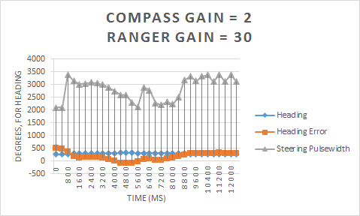

Now, with two tests to determine what effect the ranger gain has on the car, With a compass gain of 2 and a ranger gain of 0, the heading stabilizes in a more linear fashion than compared to the previous graph. The heading error also maintains at around 5600ms, 2400ms shorter than the prior entry of 8000ms. The steering pulsewidth also becomes slightly shaky and the heading error more linear, the vice versa of the previous diagram.

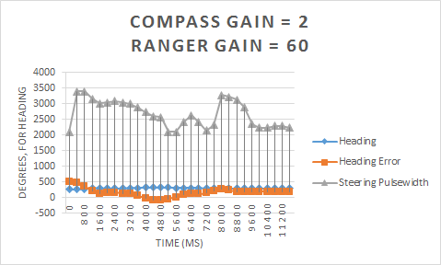

In each of these graphs, the heading takes a little while before getting to the final result before stabilizing.

Meanwhile, when we introduce a ranger gain, we have a lot more fluctuation

The pulsewidth doesn't really do much.

**Analysis of the plots should explain what is happening and why.**

**Significant features on the plots should also be noted and explained.**

**Include a discussion of how the code performs the desired control by adjusting the steering to correct the heading error.**

**Include a complete commented listing of the C code; printed with a single spaced Courier font, 10 points, left justified, with proper indenting.**